1.13.3 Blackline Master
Graphs, Tables, Equations, and Situations  Card 1  Chicken wings cost $\$0.60$ each.  Let $x$ represent the number of chicken wings purchased. Let $y$ represent the total cost of the chicken wings, in dollars. | Graphs, Tables, Equations, and Situations  Card 2  Clare always checks out the maximum number of items from the library. She can check out up to 15 items (books or DVDs).  Let $x$ represent the number of books Clare checks out. Let $y$ represent the number of DVDs Clare checks out.
Graphs, Tables, Equations, and Situations  Card 3  Tacos are $2 each and dumplings are $1 each. Han plans to spend $10 on snacks.  Let $x$ represent the number of tacos Han could buy and $y$ represent the number of dumplings Han could buy. | Graphs, Tables, Equations, and Situations  Card 4  A city puts a tax on sweetened beverages. The tax is 1.5 cents per ounce.  Let $x$ represent the number of ounces in the drink. Let $y$ represent the tax on the drink, in cents.
Graphs, Tables, Equations, and Situations  Card 5  Kiran runs for 60 minutes a day.  Let $x$ be his average speed for the day, in miles per hour. Let $y$ be the number of miles he runs in a day. | Graphs, Tables, Equations, and Situations  Card 6  A climbing gym charges $50 a month, but gives a permanent $5 discount for every person you refer to the gym.  Let $x$ be the number of people you've referred to the gym and $y$ be your monthly cost, in dollars.
Graphs, Tables, Equations, and Situations  Card 7  Mai has a snow-shoveling business. She charges a flat rate of $50 for the winter, and then an additional $5 for every snowfall over 6 inches.  Let $x$ be the number of snowfalls over 6 inches, and $y$ be the cost of hiring Mai, in dollars. | Graphs, Tables, Equations, and Situations  Card 8  Priya is using 20 meters of fencing to make a rectangular chicken run. She will use the fencing for all 4 sides of the run.  Let $x$ by the length of the run, in meters, and $y$ be the width of the run, in meters.

Graphs, Tables, Equations, and Situations
Card 9
$$x$$ | $$y$$
20 | 30
12 | 18
67.6 | 101.4
Graphs, Tables, Equations, and Situations
Card 10
$$x$$ | $$y$$
2 | 6
4 | 2
5 | 0
Graphs, Tables, Equations, and Situations
Card 11
$$x$$ | $$y$$
6 | 3.60
10 | 6.00
12 | 7.20

Graphs, Tables, Equations, and Situations
Card 12
$$x$$ | $$y$$
3 | 3
2.5 | 2.5
3.2 | 3.2
Graphs, Tables, Equations, and Situations
Card 13
$$x$$ | $$y$$
5 | 5
4 | 6
3 | 7
Graphs, Tables, Equations, and Situations
Card 14
$$x$$ | $$y$$
0 | 50
2 | 60
5 | 75

Graphs, Tables, Equations, and Situations
Card 15
$$x$$ | $$y$$
0 | 50
2 | 40
7 | 15
Graphs, Tables, Equations, and Situations
Card 16
$$x$$ | $$y$$
0 | 15
7 | 8
10 | 5

Graphs, Tables, Equations, and Situations  Card 17  $$2x+2y=20$$ | Graphs, Tables, Equations, and Situations  Card 18  $$y=15-x$$
Graphs, Tables, Equations, and Situations  Card 19  $$y=5x+50$$ | Graphs, Tables, Equations, and Situations  Card 20  $$y=0.60x$$
Graphs, Tables, Equations, and Situations  Card 21  $$2x+1y=10$$ | Graphs, Tables, Equations, and Situations  Card 22  $$y=\frac{60x}{60}$$
Graphs, Tables, Equations, and Situations  Card 23  $$1.5x=y$$ | Graphs, Tables, Equations, and Situations  Card 24  $$50-5x=y$$

Graphs, Tables, Equations, and Situations  Card 25  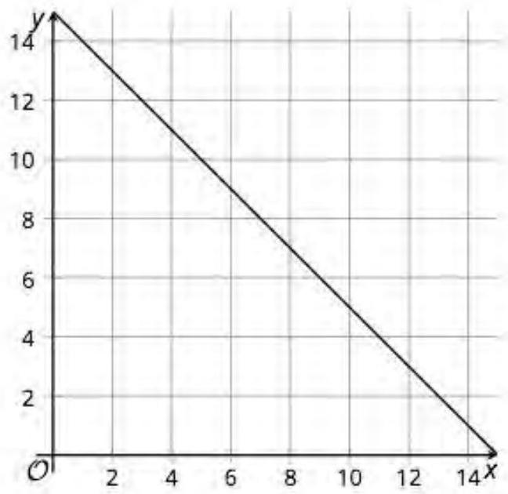 | Graphs, Tables, Equations, and Situations  Card 26  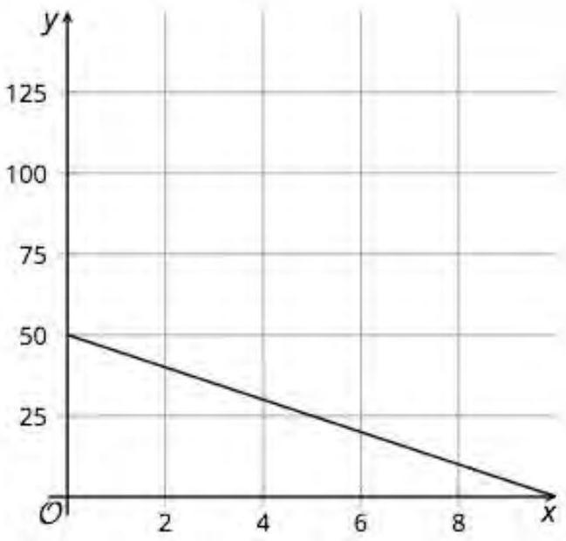
Graphs, Tables, Equations, and Situations  Card 27  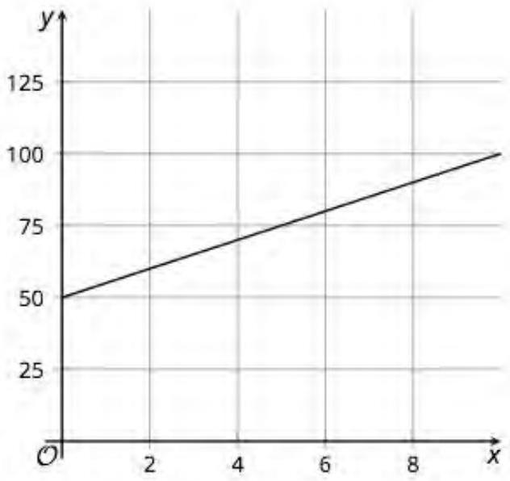 | Graphs, Tables, Equations, and Situations  Card 28  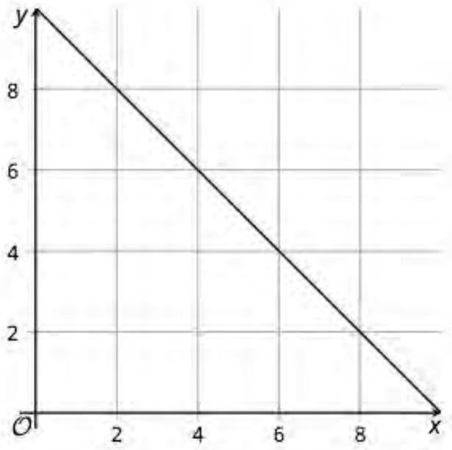
Graphs, Tables, Equations, and Situations  Card 29  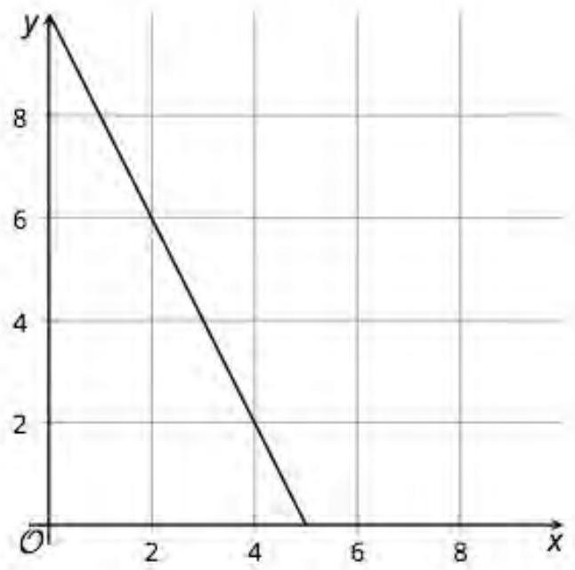 | Graphs, Tables, Equations, and Situations  Card 30  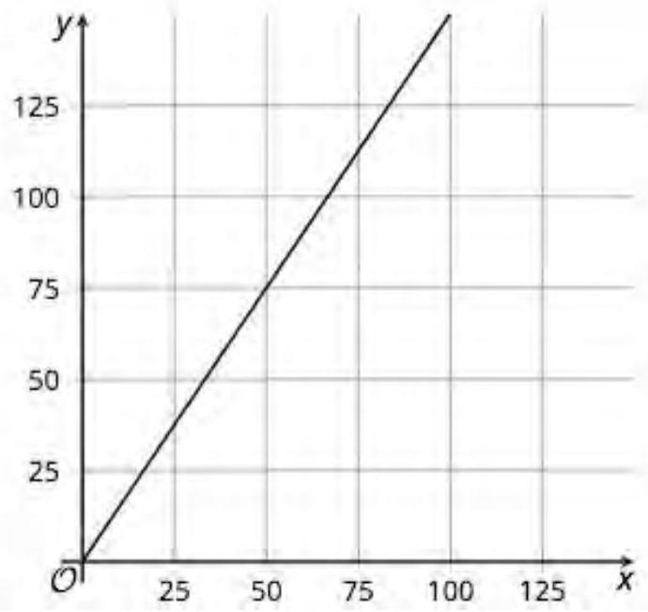
Graphs, Tables, Equations, and Situations  Card 31  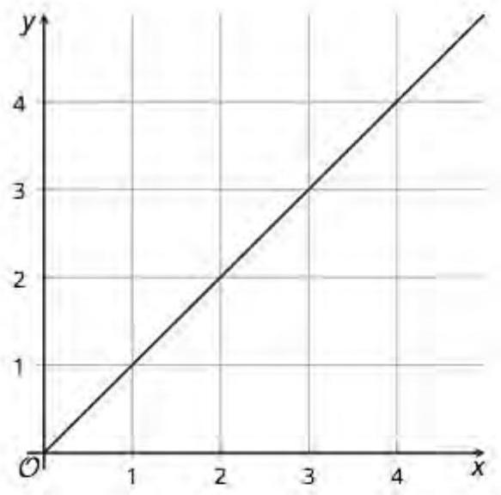 | Graphs, Tables, Equations, and Situations  Card 32  